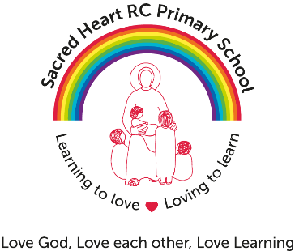

Teaching Assistant required for Sacred Heart R C Primary School
Grade: 5 point 22- 25 - £21,074 - £23,111 (pro rata)
35 hours - term time only

The Governing Body are seeking a dynamic and highly motivated Teaching Assistant with experience of working with children in Upper Key Stage 2. We are looking for someone to support our children to learn as effectively as possible, both in group situations and individually, inside and outside of the classroom.

We would like someone who will:

- Be either a practising Catholic or have a commitment to the Catholic Mission of the school
- Be an outstanding practitioner
- Possess and use appropriate skills to undertake those activities necessary to meet the physical, emotional and educational needs of individuals and groups of children including those with SEND
- Assist teaching staff in the planning, preparation, delivery and assessment of work programmes for individuals and groups of children.
- Have a commitment to working in partnership with staff, parents and parish.
Visits to the school are warmly encouraged.

Sacred Heart RC Primary School is committed to safeguarding and promoting the welfare of children and young people and expects all staff and volunteers to share this commitment.

Appointment to this post is subject to an enhanced Disclosure and Barring and background check and Childcare Disqualification Check.

The ability to converse at ease with customers and service users and provide advice in accurate spoken English is an essential requirement of this post.

Closing Date: Thursday 6th December 2018

Interview Date: Monday 10th December 2018

To apply for this position please download the CES application form and supporting documentation form which can be obtained from our school website: https://www.sacred-heart-school.org.uk/vacancies/ and send completed applications to:

cwesterman@sacredheartrc.rochdale.sch.uk by 12:00 noon Thursday 6th December 2018

