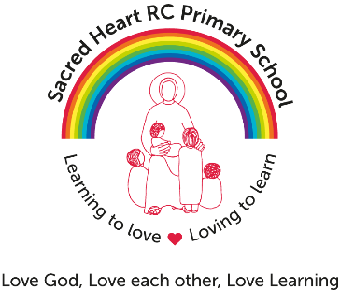

Caretaker required for Sacred Heart R C Primary School
Grade: 3 £17,681 - £18,672
37 hours – all year round

We are looking to appoint a conscientious and self-motivated caretaker who will provide a vital role in maintaining our school site, ensuring a welcoming and safe environment for the whole school community.

The successful candidate will be responsible for the general running and maintenance of the premises and will manage our cleaner.

We are looking for candidates who will take an active interest in the life of the school and enhance the excellent services that we provide, taking pride in their work and in the condition of the building and school grounds.

You will be expected to work both the early shift 07:00-10:30 and the late shift 14:00 -18:00 (Monday-Thursday), 14:00 – 17:30 (Friday) on a rotational basis and act as a key holder for the premises. However, some flexibility will be required in order to facilitate holidays, school events and meetings.

The ability to plan and undertake repairs and general maintenance to a high standard is essential along with the ability to work on your own initiative and be proactive in your approach to daily work, including some porterage and cleaning duties. Experience of working in site management/maintenance/building trades, whilst not essential, would be an advantage.

As a successful candidate you will;

- Be hard working, reliable and interact positively with children, families, staff and visitors.
- Have a good working knowledge of Health & Safety procedures
- Have good communication skills
- Be able to prioritise and manage your workload
- Be assertive, confident and level-headed when dealing with people at all levels
- Be flexible and able to work on your own initiative
- Have excellent team working skills
- Be methodical and well-organised
- Be able to work to deadlines and under pressure
- Have good basic IT skills
- Have a good sense of humour and be willing to be a part of the school community
- Where appropriate, be prepared to work with children in the school environment
- Be respectful of the Catholic Ethos of the school

Visits to the school are warmly encouraged.

Sacred Heart RC Primary School is committed to safeguarding and promoting the welfare of children and young people and expects all staff and volunteers to share this commitment.

Appointment to this post is subject to an enhanced Disclosure and Barring and background check and Childcare Disqualification Check.

The ability to converse at ease with customers and service users and provide advice in accurate spoken English is an essential requirement of this post.

Closing Date: Friday 28th September 2018

Interview Date: Friday 5th October 2018

To apply for this position please download the application form and supporting documentation and send completed applications to cwesterman@sacredheartrc.rochdale.sch.uk by 12:00 noon Friday 28th September 2018

