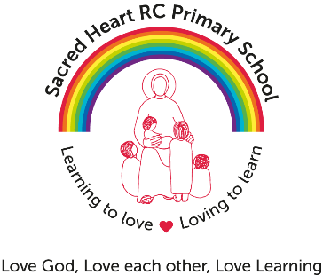

Cleaner required for Sacred Heart R C Primary School
Grade: 2 (£16,863 pro rata) Actual Salary £6,843)
15 hours/week – all year round
We are looking to appoint a conscientious and self-motivated cleaner who will provide a vital role in maintaining our school site, ensuring a welcoming and safe environment for our whole school community.
The successful candidate will be responsible for the general cleaning of the premises.
We are looking for candidates who will take an active interest in the life of the school and enhance the excellent services that we provide, taking pride in their work and in the condition of the buildings.
We are looking for someone who will:
- Be hard working, reliable and interact positively with children, families, staff and visitors.
- Have a good working knowledge of Health & Safety procedures
- Have good communication skills
- Be assertive, confident and level-headed when dealing with people at all levels
- Be flexible and able to work on your own initiative
- Have excellent team working skills
- Work closely with the caretaker
- Be methodical and well-organised
- Be able to work to deadlines
- Have a good sense of humour and be willing to be a part of the school community
- Where appropriate, be prepared to work with children in the school environment
- Be respectful of the Catholic Ethos of the school
The school is committed to safeguarding and promoting the welfare of young people and expects all staff and volunteers to share this commitment. The post is subject to an enhanced disclosure from the Disclosure and Barring Service.
If you require further details, please contact Mrs C Westerman, email: cwesterman@sacredheartrc.rochdale.sch.uk. Tel: 01706 649981
Applications to be received by: 12.00 Noon on Friday 28th September 2018
Interviews : Friday 5th October 2018

